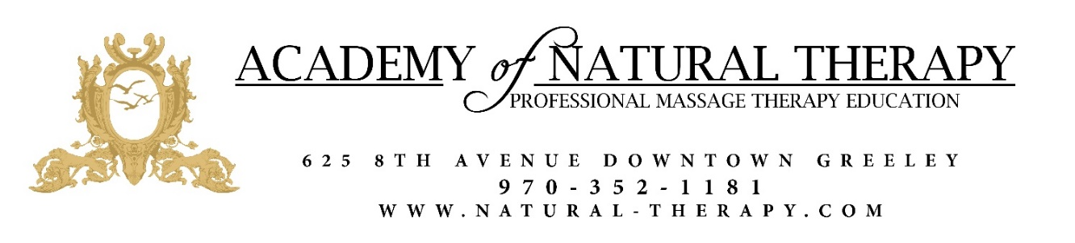
2021 Additional Classes

Advanced neuromuscular therapy… August 5th , 2021 -October 7th, 2021
(Thursday 5-9pm)
This course examines in detail the cause and effect of neuromuscular injuries. Relevant concepts will include postural positions, nerve interruption locations, deep-tissue myofascial release, advanced injury assessment, and palpating techniques. ($800) (40 Hours)
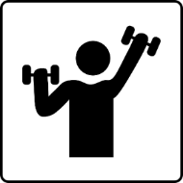
Nutrition & Exercise…August 3rd, 2021 to October 4th 2021
(Tuesday 1-5pm)
This course will provide students with a basic understanding of nutrition and health, as well as an understanding of the correlation between stress and wellness, and lifestyle and wellness. Students will learn the remedies which massage therapists use to create a general well-being for their clients. ($600) (30 hours) (open to public)

Reflexology… October 19^{t,h} 2021- January 7th, 2022 (Tuesday 1-5pm)
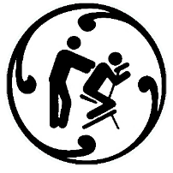
Reflexology has been used for centuries as a tool to help heal the body as a whole. Students are taught an introduction to this ancient healing technique. Reflexology has been used to increase body functions with reflex point stimulation on the hands and feet. Students learn proper body mechanics, zone therapy, and full session reflexology procedures. **To receive certification, one must complete 20 internship hours in Reflex. ($800) (40 Hours)

Movement therapies… October 22nd -January 7th, 2022 (Friday 5-9pm)
This class combines student learning with client education/ rehabilitation techniques. Studying common movements in everyday life through anatomy and kinesiology movements. Being able to understand how these movements performed repetitively can contribute to postural dysfunction. Students will also learn different exercises, stretches, and strengthening exercises that will be used in the clinical setting to help rehabilitate muscle groups, functional fitness will enhance balance and stability. ($800) (40 Hours)

MARKETING … October 22nd -January 7th, 2022 (Friday 1-5pm)
This course shows students the basics for marketing methods, institutions, and practices. Looking at product concept and design, distribution, alternatives, promotion, advertising programs, and pricing decisions. It also holds on to the psychology of customer needs, satisfaction, and retention. ($800) (40 Hours) open to public)

2022 Additional Classes
OPERATIONS AND CLINIC MANAGEMENT … January 17th, 2022 -March 22nd, 2022 (Tuesday 5-9)
This course shows students the basics for management, learning insurance billing, business plans, success strategies, advertising, marketing, fees, locations, bookkeeping, tax information, and basic business licensing. ($760) (40 Hours)

Teaching methods… January 21st, 2022 -March 25th, 2022 (Friday 5-9)
This course shows experienced students the teaching profession. It will look at teaching styles, learning styles, and different educational techniques. It will also be able to provide tactics in preparing lesson plans, syllabi, and structuring courses to follow objectives, competencies, and mission statements that will be able to conclude with methods of materials utilized to obtain maximal results. ($800) (40 Hours)
Prenatal… January 20th, 2022 -March 24th, 2022 (Thursday 1-5)
This course shows students how to do safe, supportive massage to relieve the physical discomforts of pregnancy, assist in a meaningful way during labor and delivery, and help in the recovery process following birth. Students learn contraindications to prenatal massage and positioning concerns during the trimesters. Students also learn the benefits and applied techniques of infant massage. ($720) (36 Hours)

Shiatsu… January 18th, 2022 -March 24th, 2022 (Tuesday 1-5)
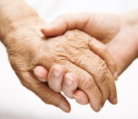
Shiatsu massage is the art of gentle manipulation using hands, fingers, and foot pressure to these various points, which influence the chi flow throughout the body and create balance and harmony to the entire system. This course provides the student with an introduction to Asian healing theory. Emphasis is on the practical application of shiatsu ($800) (40 Hours)

Canine massage…April 6th, 2022- June 8th, 2022 (Wednesday 1-5)
In this course, students will learn the many ways which massage can benefit canine health. An introduction to the canine muscle functions will be taught in addition to the massage techniques used to promote canine relaxation, pain relief, flexibility, oxidation, and more. ($800) (40 hours) open to public)
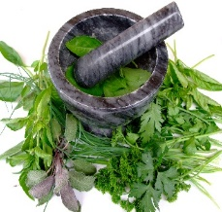
Herbology…April 8th, 2022-June 10th, 2022 (Wednesday 1-5)
Students learn how to reference legitimate sources of information in preparation for being a knowledgeable resource for their clients. Class activities include selection and care of plants and preparation of tinctures. ($800) (40 Hours) (open to pubic)

Orthopedic Massage…June 23rd - August 25th, 2022
(Thursday 1-5)
This course examines techniques including therapeutic assessment skills, manipulation, and movement of soft tissues to reduce pain and dysfunction. Using multidisciplinary methods to restore structural balance throughout the body, learning to focus on prevention and rehabilitation of musculoskeletal dysfunction, chronic and acute pain, and many injuries. ($800) (40 Hours)

Lymphatic Drainage…June 24th – August 26th, 2022 (Friday 5-9)
Lymphatic Drainage is a gentle, rhythmic form of massage which mimics the lymphatic system. Students will learn how to use massage to open the initial lymphatics and stimulate lymph vessel contractions to reduce edema. Students will review their knowledge of the lymphatic system as they are taught the theories and basic techniques of Lymphatic Drainage Massage. ($800) (40 Hours)

Nutrition & Exercise…June 21st – August 23rd, 2022 (Tuesday 1-5)
This course will provide students with a basic understanding of nutrition and health, as well as an understanding of the correlation between stress and wellness, and lifestyle and wellness. Students will learn the remedies which massage therapists use to create a general well-being for their clients. (600) (30 Hours) (open to public)

Medical Massage…September 5th – November 7th, 2022 (Monday 5-9)
This course is supposed to go into therapeutic bodywork delivered in a medical setting, under the direction of a doctor or other health care providers. Medical massage has advanced training in massage techniques, pathology & contraindications, medical communication & documentation, insurance billing, professional ethics and legal issues. ($800) (40 Hours)

Special Needs Massage…September 6th – November 8th, 2022 (Tuesday 5-9)
The purpose of this course is to address a non-typical client who could benefit from Massage Therapy. The student will explore different massage techniques transferring techniques, intake and contraindicates to help those extraordinary people such as disabled children, the elderly, the handicapped, and the injured. ($800) (40 Hours)

Reflexology… September 5^{t,h} 2021- November 7th, 2022 (Monday 1-5)
Reflexology has been used for centuries as a tool to help heal the body as a whole. Students are taught an introduction to this ancient healing technique. Reflexology has been used to increase body functions with reflex point stimulation on the hands and feet. Students learn proper body mechanics, zone therapy, and full session reflexology procedures. **To receive certification, one must complete 20 internship hours in Reflex. ($800) (40 Hours)

Prenatal… September 8th – November 10th, 2022 (Thursday 1-5)
This course shows students how to do safe, supportive massage to relieve the physical discomforts of pregnancy, assist in a meaningful way during labor and delivery, and help in the recovery process following birth. Students learn contraindications to prenatal massage and positioning concerns during the trimesters. Students also learn the benefits and applied techniques of infant massage. ($720) (36 Hours)

