NorCoWIB Parking: Per our conversation, we will provide a parking waiver for the below circled blue area’s on October 7th between 8 - 10:30 AM.

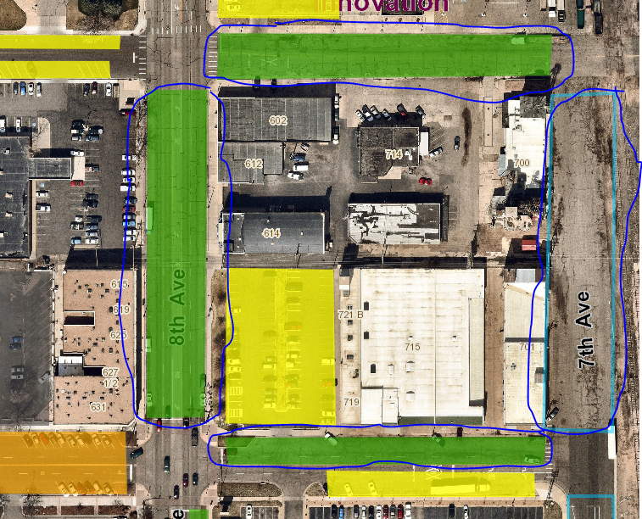

Respectfully,

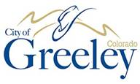

**Will Jones**